Project Planning Phase
Project Planning Template (Product Backlog, Sprint Planning, Stories, Story points)

Date | 15 February 2025
Team ID | SWTID-2026-3395
Project Name | Visualizing Housing Market Trends
Maximum Marks | 5 Marks

Product Backlog, Sprint Schedule, and Estimation (4 Marks)
Use the below template to create product backlog and sprint schedule
Sprint | Functional  Requirement (Epic) | User Story  Number | User Story / Task | Story Points | Priority | Team  Members
Sprint-1 | Registration | USN-1 | As a user, I can register for the application by entering my email, password, and confirming my password. | 2 | High | Team
Sprint-1 | Registration | USN-2 | As a user, I will receive confirmation email once I have registered for the application | 1 | High | Team
Sprint-1 | Registration | USN-3 | As a user, I can register for the application through Facebook | 2 | Low | Team
Sprint-1 | Registration | USN-4 | As a user, I can register for the application through Gmail | 2 | Medium | Team
Sprint-1 | Login | USN-5 | As a user, I can log into the application by entering email & password | 1 | High | Team
Sprint-2 | Housing Data Visualization | USN-6 | As a user, I can view housing price trends through charts and graphs. | 4 | High | Team
Sprint-2 | Housing Data Visualization | USN-7 | As a user, I can filter housing data by city and year | 3 | High | Team
Sprint-2 | Housing Data Visualization | USN-8 | As a user, I can view location-wise housing market analysis | 3 | Medium | Team

Project Tracker, Velocity & Burndown Chart: (4 Marks)
Sprint | Total Story Points | Duration | Sprint Start Date | Sprint End Date (Planned) | Story Points  Completed (as on  Planned End Date) | Sprint Release Date (Actual)
Sprint-1 | 8 | 6 Days | 20 Jun 2026 | 25 Jun 2026 | 8 | 25 Jun 2026
Sprint-2 | 10 | 6 Days | 26 Jun 2026 | 01 Jul 2026 | 10 | 01 Jul 2026
Sprint-3 | 10 | 6 Days | 02 Jul 2026 | 07 Jul 2026 | 10 | 07 Jul 2026
Sprint-4 | 5 | 8Days | 08 Jul 2026 | 15 Jul 2026 | 5 | 15 Jul 2026

Velocity:
Imagine we have a 10-day sprint duration, and the velocity of the team is 20 (points per sprint). Let’s calculate the team’s average velocity (AV) per iteration unit (story points per day)
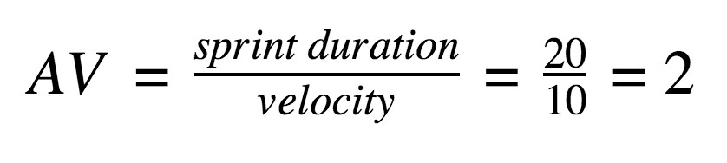

Burndown Chart:
A burn down chart is a graphical representation of work left to do versus time. It is often used in agile software development methodologies such as Scrum. However, burn down charts can be applied to any project containing measurable progress over time.

https://www.visua
l
-
paradigm.com/scrum/scru
m
-
burndow
n
-
chart
/

https://www.atlassian.com/agile/tutorials/burndow
n
-
chart
s

Reference:

t
https://www.atlassian.com/agile/projec
-
managemen
t

https://www.atlassian.com/agile/tutorials/ho
w
-
t
o
-
d
o
-
m
scru
-
wit
h
-
jir
a
-
softwar
e

https://www.atlassian.com/agile/tutorials/epic
s

https://www.atlassian.com/agile/tutorials/sprint
s

https://www.atlassian.com/agile/projec
t
-
management/estimatio
n

https://www.atlassian.com/agile/tutorials/burndow
n
-
chart
s

